**Water Quality Data Collected On Long Island Sound & The Hudson River as part of the River Summer Program, July 2011 (**[**www.riversummer.org**](http://www.riversummer.org)**)**

**What Are you looking at when you look at these “section maps”? The maps are visualizations or data that look at the water in a sideways slice. It is as if we were looking at the water through the side of an aquarium and are able to see right through the glass side of the Hudson River to see the salinity, oxygen, temperature etc. color coded. In the two sets of data the X axis is latitude and the Y axis is the units of measure. The data was collected by dropping a CTD (Conductivity, Temperature and Density) instrument down the water.**

**To summarize: Two methods of water sampling were employed for RS2011: a) Surface Sample Data which was collected using a handheld YSI multi-parameter instrument (collecting Temperature, Salinity, Dissolved Oxygen (DO), pH, Oxygen Reduction Potential (orp)) and a secchi disc for turbidity (water clarity); b) CTD (conductivity, temperature, depth) instrument that collects a profile of measurements down the water column (Temperature, Salinity, Density, Obs [optical backscatter, a measure of turbidity], DO and Fluorescence [a measure of chlorophyll or productivity in the water]). While collecting both sets of data might seem redundant, we collect both since at the water surface the CTD does not collect as accurate a measure as deploying the YSI at the surface.**

**The CTD data has been placed into sections and plotted the sections on a map adding some notes beneath the maps so that you can see how the water changes not only as you move down the water column, but also as you move through LIS, the East River and up the Hudson. This makes examining the data much more meaningful. The YSI data is in an excel file and has not been visualized but can easily be compared to the sections or put into graphs for further analysis. The secchi disc measurements in the excel data set shows a clear drop in visibility once you reach the Hudson River (mirrored in the CTD data), an expected but fun to observe finding. The Hudson is known to be a turbid waterbody, a function of its role as an estuary.**

**Note: If you compare section data between LIS and HR carefully check the scales selected on each. The scales were selected to improve the visualization of each specific dataset and are not the same between the two different datasets. Especially be aware of the Obs (turbidity) and Florescence (productivity) as these scales vary significantly between the two. If you are looking to compare the two this needs to be taken into account.**

**A couple of things to be aware of as you look at the CTD data:**

1. **the first set of visualizations is for the Long Island Sound and East River. The map shows 10 data points highlighted, but the casts only include the first 9 casts – the last data point (which is at Battery Park City) is actually included in the Hudson River visualizations not the LIS ones;**
2. **as we transited you might have heard Capt. Steve discuss where the East River starts and where the LIS ends – there is no exact agreement on this and since we have showed the data as continuous it doesn’t really matter, however in the excel file where we have noted the names of the locations we called cast #7 our first ER cast (our last cast on 7/7/11 at Stepping Stones before we docked for the night);**
3. **The LIS visualizations are straight forward to look at as they run E to W by longitude just like the sound does and can be lined up right under the map. The HR visualizations run South to North by latitude so think left to right moving from downriver (Battery) to upriver (Bear Mountain) as you review the data. Viewing the salinity might help with orienting to this as the salinity moves from being dominated by salty (Atlantic input) to fresh (Upper Hudson/Mohawk input);**
4. **LIS, ER and HR are connected waterbodies. LIS has primarily Atlantic Ocean water input keeping it salty and cool (although there are several CT tributaries that add fresh water which brings the salinity down from ocean levels of ~35 ppt), the ER is a strait connecting LIS and the HR with the salinity lowering and the temp. increasing as you move from LIS to the HR (which has a large fresh water input from the northern section of the watershed);**
5. **If you look at the surface sample file you will note that the ER sampling had cooler temps. – but this sampling was done in the early AM accounting for this cooling at the surface, this cooling does not extend down the water column as you can see in the section data;**
6. **In the visualaizations the casts can be seen as dashed lines in the image and between these images the data are extrapolated to create a best fit image;**

**Enjoy and let us know if you have questions!**

**Margie & Tim**

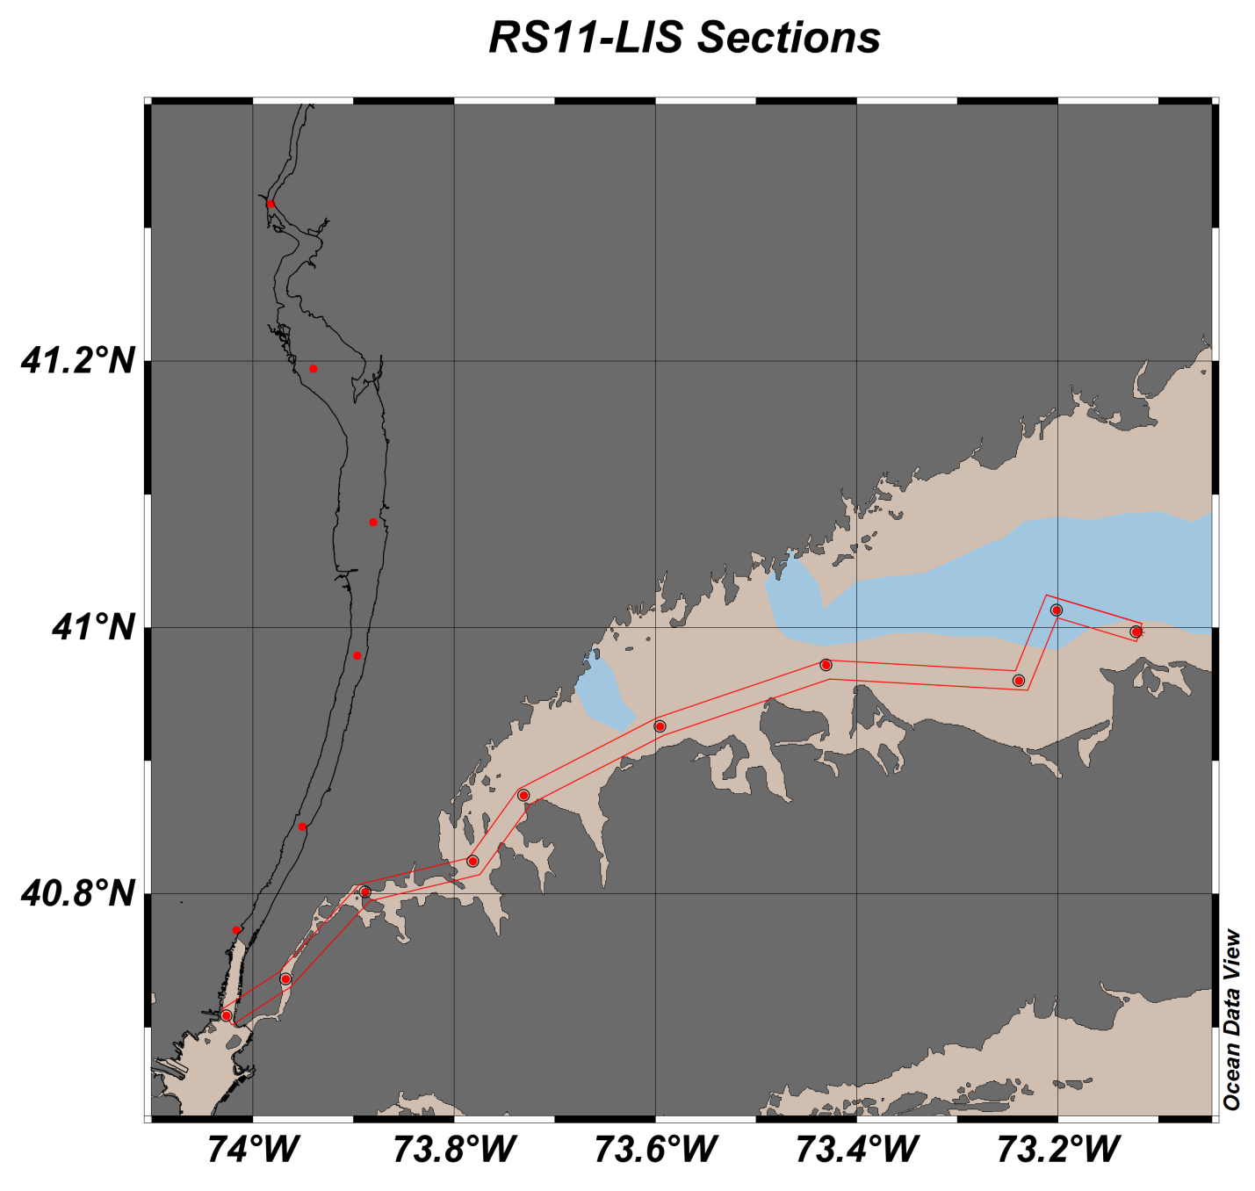

Long Island Sound (LIS) moving east to west we observe colder, saltier water in LIS compared to the relatively warmer, fresher Hudson, notice the similarity between salinity and density. Optical backscatter, a measure of turbidity, indicates a higher concentration of suspended particles in water originating from the Hudson; also, examine the Secchi disk data and compare it to OBS. We observe regions of low dissolved oxygen related to seasonal hypoxia in Smithtown Bay (3rd station from the right) and at the western end of LIS (6th station from the right; Execution Rocks). Also note that water originating from the Hudson exhibits DO values that are generally lower than those in LIS. Fluorescence indicates higher productivity in the surface waters of LIS and a maximum in western LIS.

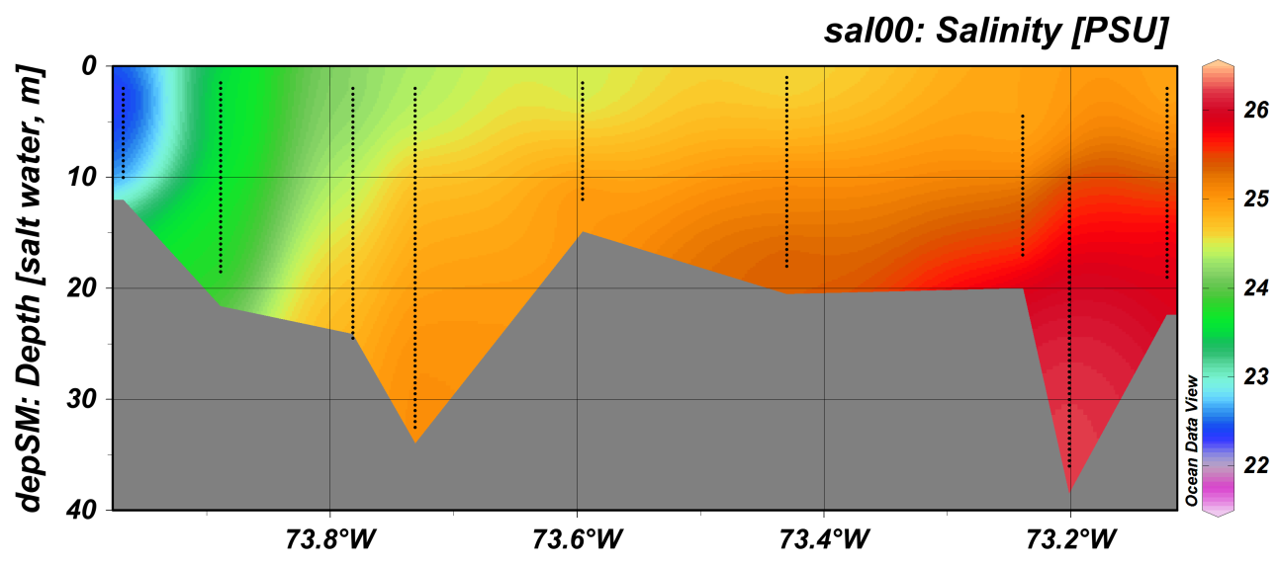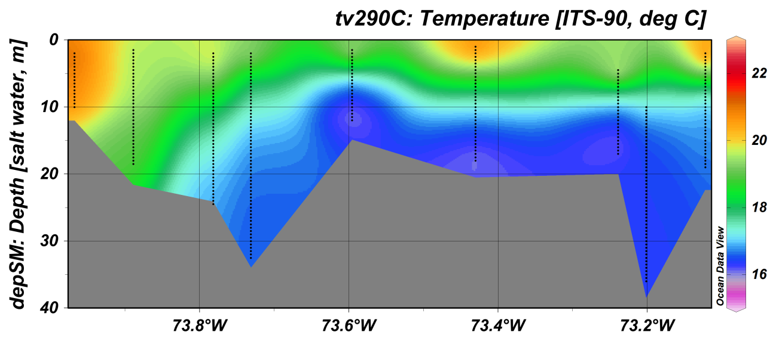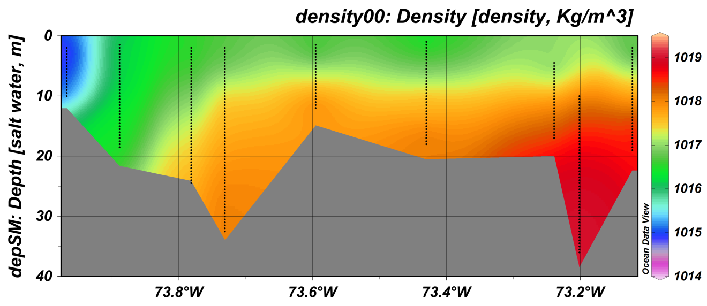

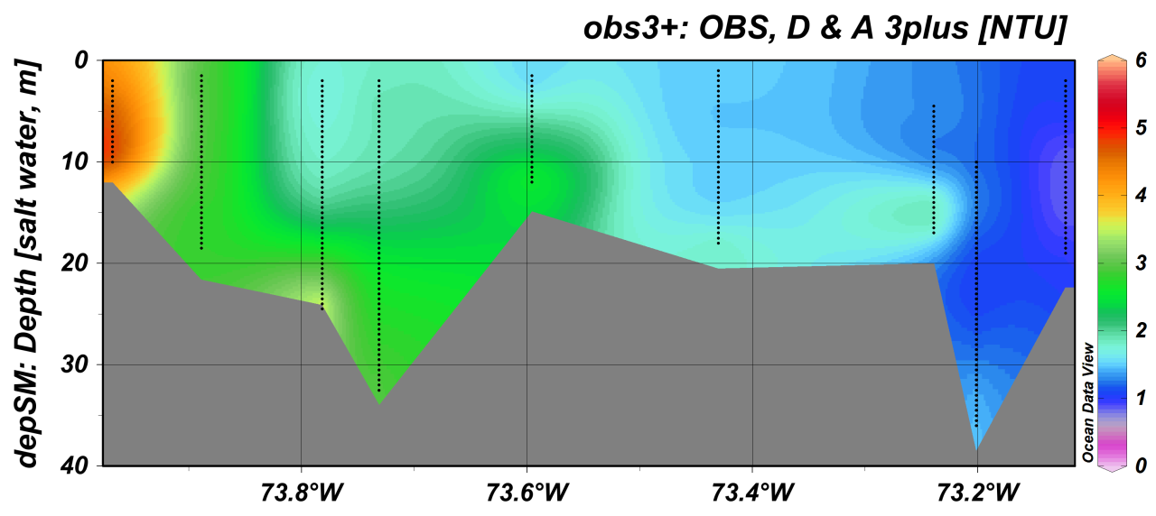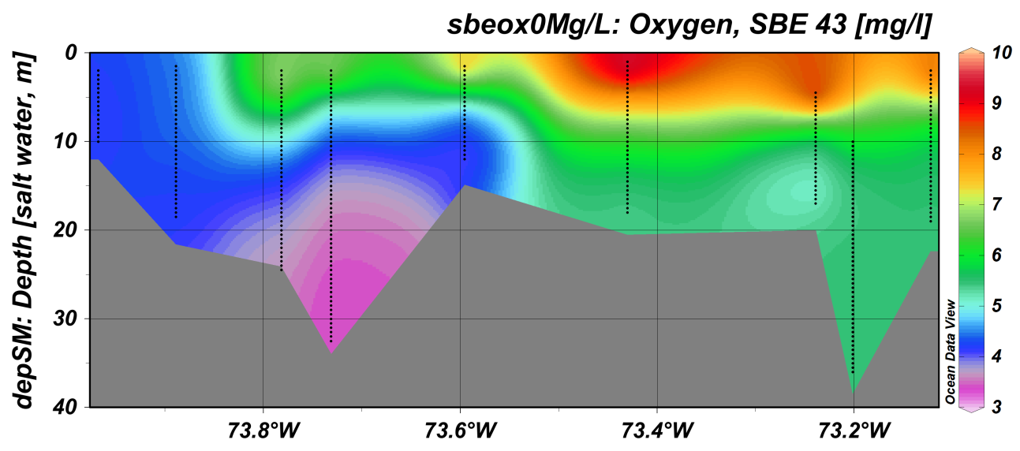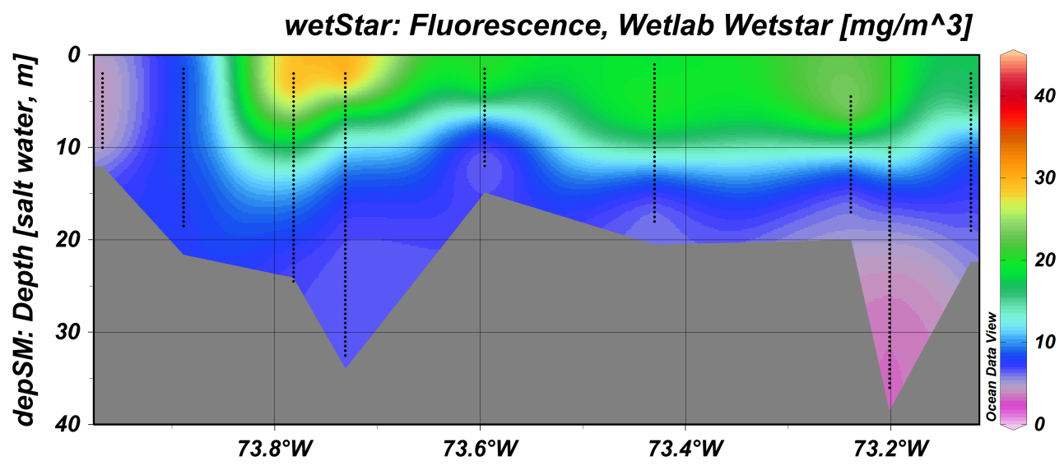

***RS11-HR Sections***

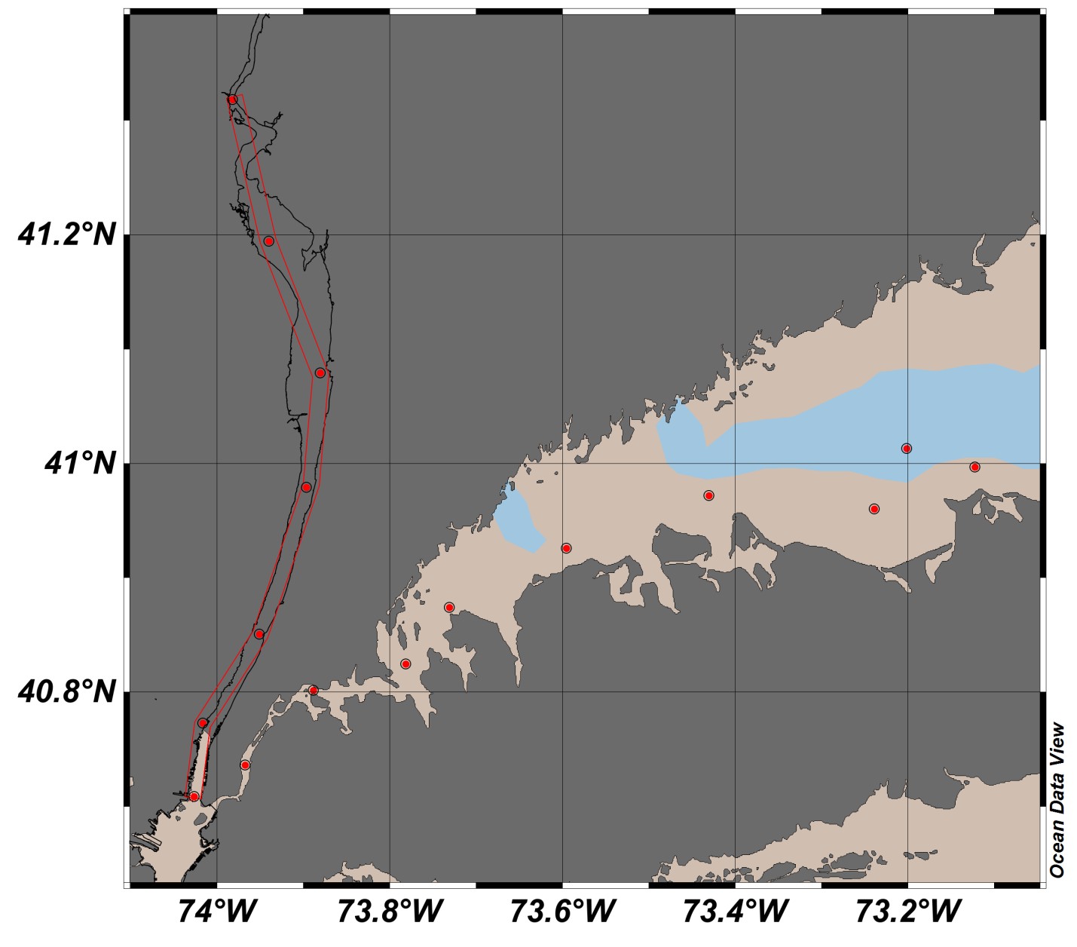

Hudson River (HR) moving south to north, we observe a fine example of density driven estuarine circulation. The denser (colder and salter) water originating from the south (ocean) travels northwards along the bottom, while the less dense (warmer and fresher) water originating from the north (land) travels southwards along the surface – the gradient between shows the mixing and extent of the salt front. The OBS data is also interesting – note the area of higher backscatter; this is the estuarine turbidity maximum (ETM). Also note that the ocean water is lower in productivity than HR water. In the images below South is to your left and North is to your right.

